BridgePrep Academy of South Tampa

batampa.BridgePrepAcademy.com

Christine N. Harris, M. Ed.

Principal

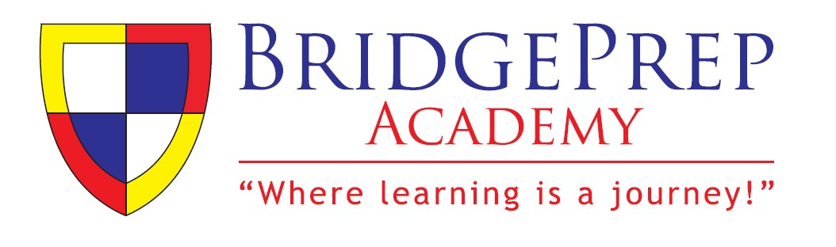

# **2019 – 2020 SCHOOL SUPPLY LIST for Grade 2nd through 8th**

ITEMS BELOW (CLASSROOM MATERIALS) ARE TO BE LEFT AT SCHOOL FOR COMMUNITY USE.

## PERSONAL ITEMS THAT GO BEYOND THIS LIST SHOULD BE MARKED (WITH NAME) AND REMAIN WITH CHILD. WE WILL NOT REPLACE LOST OR STOLEN ITEMS. AT MINIMUM, THESE BELOW ITEMS ARE NEEDED AND STORED WITH CLASSROOM TEACHER TO UTILIZE UPON CHANGING OF QUARTERS OR ON DEMAND FOR INSTRUCTIONAL PURPOSES. THANK YOU, IN ADVANCE, FOR YOUR UNDERSTANDING

|  |  |  |
| --- | --- | --- |
| **Student Materials** | **Classroom Materials** | **Uniforms** |
| **PERSONAL**   * Calculator TI-30Xa   (MIDDLE SCHOOL  ONLY) o 1 PERSONAL Pencil  Pouch o 1 **PERSONAL Headphones (labeled with child’s name)**   * **1 jump drive / USB Flash Drive (label with name)** o   *CLEAR BACKPACK –*  *ALSO OFFERED BY IBILEY*    **COMMUNICATION**  **FOLDERS**    **BridgePrep PLANNER /**  **AGENDA BOOKS for**  PARENT/TEACHER  *Communication &*  *Homework*    **BPA Planner = required for purchase on campus** $7.00 each. | 2 Expo Dry Erase Markers or 1 box  2 Box of Tissue  1 Container of Anti-Bacterial  Wipes  1 Hand Sanitizer  1 Box of Ziploc Bags (1 Gallon &  1 Sandwich)  1 Roll of Paper Towels  3 Packs of #2 Pencils with erasers  1 Box of Colored Pencils  4 Glue Sticks  1 Pack Multi-Colored Highlighter  1 Ruler  1 Box of Crayons (Art)   1. Pack of Index Cards (3X5) 2. Reams/Packs of Copy Paper   2 Pack of Wide-Ruled Paper  2 Pack of 3X3 Post-It Notes    **12 *One-Subject* Spiral Notebooks:**   * 2 **Red** (Language Arts) * 2 **Purple**(Social Studies) * 2 **Blue** (Math) * 2 **Green** (Sci) * 2 Yellow (Spanish) * 1 ***4 subject*** notebook for   ELECTIVE(s) - Middle  School ONLY | **BOTTOMS** = Navy or Khaki Long  Shorts, or Long Skirts - see Parent/Student Handbook online (under the parent tab):  http://batampa.bridgeprepacademy  .com/      **TOPS** = White, Light Blue (sky), or Navy must have **BridgePrep Logo Shirts** as provided by Ibiley Please order via: http://www.ibiley.com/default.asp x    **SHOES** = Black, Navy, or White close toed shoes/sneakers (no heels). One color monochromatic highly encouraged. Multiple colors, lights, and rollers are prohibited.    *\*Uniforms are mandatory and a staple for our children as well as our way of work. Please abide by this school policy. Phone calls and pickups for “out of uniform students” will occur.*    ***Grades 6-8 Lead Day Attire (see***  ***Website for details)*** |

***\*Any parent/family willing to purchase extra materials will receive 1 volunteer hour! This helps us ensure all children are set up for success! Thank you for your consideration :D***

BridgePrep Academy of South Tampa

batampa.BridgePrepAcademy.com

Christine N. Harris, M. Ed.

Principal



***\* UNIFORMS are mandatory and those within code but outside uniform will receive a verbal / written warning prior to being called home for change of clothes. HOWEVER, those students with inappropriate attire (ripped pants, jeans, t-shirts, hoodies, etc.) will be called home immediately for a change of clothes in order to return to class.***

# Home of the Bears

West Swann Avenue • Tampa , FL 33609 • Phone: 813-258-5652