Suzanne Mizzi, M.Ed. , AP

BridgePrep Academy of South Tampa

batampa.BridgePrepAcademy.com

Christine N. Harris, M. Ed.

Principal

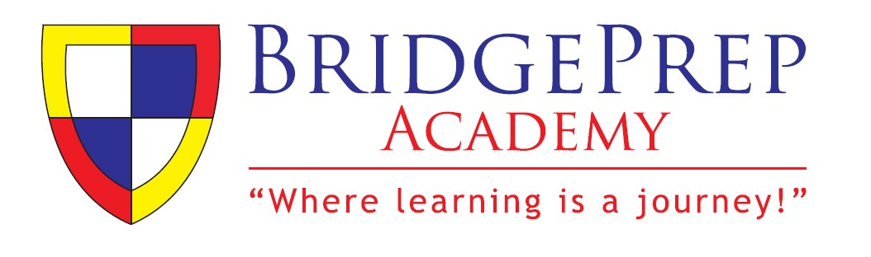

# **2019 – 2020 SCHOOL SUPPLY LIST - Grade K through 1st**

ITEMS BELOW (CLASSROOM MATERIALS) ARE TO BE LEFT AT SCHOOL FOR COMMUNITY USE.

PERSONAL ITEMS THAT GO BEYOND THIS LIST SHOULD BE MARKED (WITH NAME) AND

REMAIN WITH CHILD. WE WILL NOT REPLACE LOST OR STOLEN ITEMS. AT MINIMUM, THESE

BELOW ITEMS ARE NEEDED AND STORED WITH CLASSROOM TEACHER TO UTILIZE UPON

CHANGING OF QUARTERS OR ON DEMAND FOR INSTRUCTIONAL PURPOSES. THANK YOU, IN ADVANCE, FOR YOUR UNDERSTANDING. WE TRULY APPRECIATE ALL OF YOUR SUPPORT! WE WELCOME ANY EXTRA SUPPLIES FAMILIES ARE WILLING TO DONTATE.

|  |  |  |
| --- | --- | --- |
| **Student Materials** | **Classroom Materials** | **Uniforms** |
| 4 Primary Composition Books  (Wide Lines)  1 Ruler  1 Pencil Pouch  1 **PERSONAL Headphones labeled with child’s name**     1. Change of clothes in paper bag with name of child for incidents that may occur.       **COMMUNICATION FOLDERS**     1. **Red 2-Pocket Folder with**   **Prongs/Brads** =  PARENT/TEACHER  *Communication & Homework for*  *each quarter*     |  |  | | --- | --- | | **2 Yellow 2-Pocket Folder with** | | | **Prongs/Brads** | = *Spanish Folder* | | 1. Kid Scissors 2. Expo Dry Erase Marker   1 Box of Tissue  1 Container of Anti-Bacterial  Wipes  1 Hand Sanitizer   1. Box of Ziploc Bags (1 Gallon   & 1 Sandwich)   1. Roll of Paper Towels 2. Packs of #2 Pencils   1 Box of Colored Pencils  4 Glue Sticks   1. Liquid Glue 2. Highlighters   2 Large Pencil Erasers  2 Packs of Handwriting Paper (wide ruled – one for core class one for Spanish class) 2 24 Count Crayola Crayons  4 Reams/Packs of Copy Paper  1 Pack of 3X3 Post-It Notes | **BOTTOMS** = Navy or Khaki Long Shorts, or Long Skirts - see Parent/Student Handbook online (under the parent tab): http://batampa.bridgeprepacade  my.com/      **TOPS** = White, Light Blue  (sky), or Navy must have **BridgePrep Logo Shirts** as provided by Ibiley Please order via:  http://www.ibiley.com/default.a spx    **SHOES** = Black, Navy, or  White close toed shoes/sneakers  (no heels). One color monochromatic highly encouraged. Multiple colors,  lights, and rollers are prohibited.    *\*Uniforms are mandatory and a staple for our children as well as our way of work. Please abide by this school policy. Phone calls and pick-ups for “out of uniform students” will occur.* |

***\*Any parent/family willing to purchase extra materials will receive 1 volunteer hour! This helps us ensure all children are set up for success! Thank you for your consideration :D***

# Home of the Bears

***\* UNIFORMS are mandatory and those within code but outside uniform will receive a verbal / written warning prior to being called home for change of clothes. HOWEVER, those students with inappropriate attire (ripped pants, jeans, t-shirts, hoodies, etc.) will be called home immediately for a change of clothes in order to return to class.***

BridgePrep Academy of South Tampa

batampa.BridgePrepAcademy.com

Christine N. Harris, M. Ed.

Principal



Home of the Bears West Swann Avenue • Tampa, FL 33609 • Phone: 813-258-5652